
Year 8 Mathematics
Investigation 2 - Number Square Patterns
Name: Total: 36
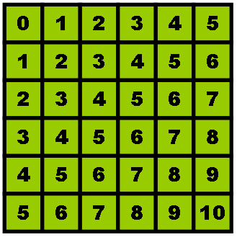
Question 1 (9 marks)
Draw an outline around any 2 by 2 square. Hint: Draw at least 3 other 2 by 2 squares in different places to see the patterns clearly. (1 mark)
- Look at the numbers in the square. What patterns do you see?
(2 marks)

- Use addition to find another pattern. Give 3 examples. (3 marks)

- Use multiplication to find another pattern. Give 3 examples. (3 marks)
Question 2 (9 marks)
Draw an outline around any 3 by 3 square. Repeat the process by drawing another 3 outlines around different 3 by 3 squares. (1 mark)

- What patterns do you see? (2 marks)

- Use addition to find another pattern. Give 3 examples. (3 marks)

- Use multiplication to find a pattern with the four corner numbers.
Give 3 examples. (3 marks)

Question 3 (9 marks)
Draw an outline around a larger square. (1 mark)

What patterns do you see that are similar to the patterns you saw for the smaller squares? (8 marks)

Question 4(9 marks)
- What is the sum of any three horizontally adjacent numbers? Give 3 examples. (3 marks)

- Describe a general rule to calculate the sum of any three horizontally adjacent numbers. (The answer is not to add all the numbers) (1 mark)

- What is the sum of any four vertically adjacent numbers? Give 3 examples. (3 marks)

- Describe a general rule to calculate the sum of any four vertically adjacent numbers. (1 mark)

- What is the general rule to calculate the sum of any five vertically or horizontally adjacent numbers. (1 mark)

